

SRI KRISHNA ARTS AND SCIENCE COLLEGE
COIMBATORE

PROJECT FOR POWER BI
FLIPKART SALES ANALYSIS

BY:
GOBINATH J
24BCO210

INDEX

SNO | CONTENT
1 | DETAILS OF PROJECTS
2 | DETAILS OF DATASETS
3 | ABOUT AND INTRODUCTION
4 | ANALYSIS OF CHART
5 | QUERY OF THE CHART
6 | DASHBOARD
7 | CONCLUSION

FLIPKART SALES ANALYSIS REPORT

1.Details
Flipkart Sales Analysis
Prepared by: Gobinath J
Dataset: flipkart_sales.csv

2.datasets
Column are:
- Order ID
- Product name
- Category
- Price
- Quantity sold
- Total sales (INR)
- Order Date
- Payment Method
- Customer rating
Rows contains 1099 rows.

3.About: AND Introduction
This project about the sales analysis of Flipkart. This the performance dashboard which includes of different types of chat like pie chart, donut chart, water fall chart, ribbon chart and the slicer.

4.Analysis:
Image:
The image is used to import the download image. I had imported the Flipkart logo in the dashboard [source: www.google.com]
Add Text:
The add text I have used to show the title/heading name
Card:
A Card shows one aggregate value, such as:
- Total Sales
- Average sales
- Maximum sales
- Minimum sales
Slicer:
I have used the slicer to show the product name and its price
Water fall chart:
The water fall chart is use to compare the sum of price and category
Pie chart:
The pie chart is use to compare the sum of price and category
Donut chart:
The donut chart is used to compare the sum of quality sold and category
Clustered bar chart:
The clustered bar chart is to compare the payment method and sum of price

Line chart:
The ribbon chart is used to compare the sum of quantities sold and the category

Clustered column chat:
The clustered column chart is used to compare the product name and sum of the price (INR)
Ribbon chart:
The ribbon chart is used to compare the product name and total sales by the product name
Matrix table:
The matrix table is used to compare the and the category of the products
Funnel chart:
The funnel chart is used to compare the category and the sum of prices
Gauge:
The Gauge chart is used to show sum of price and the product name
5.query:
1. total sales = SUM ('Flipkart sales (1)'[Total Sales (INR)])
2. avg sales = AVERAGE ('Flipkart sales (1)'[Total Sales (INR)])
3. max sales = MAX ('Flipkart sales (1)'[Total Sales (INR)])
4. min sales = MIN ('Flipkart sales (1)'[Total Sales (INR)])

6.
the page 1 includes of image, add text, card, slicer, water fall chart, pie chart, donut chart, clustered bar chart and line chart
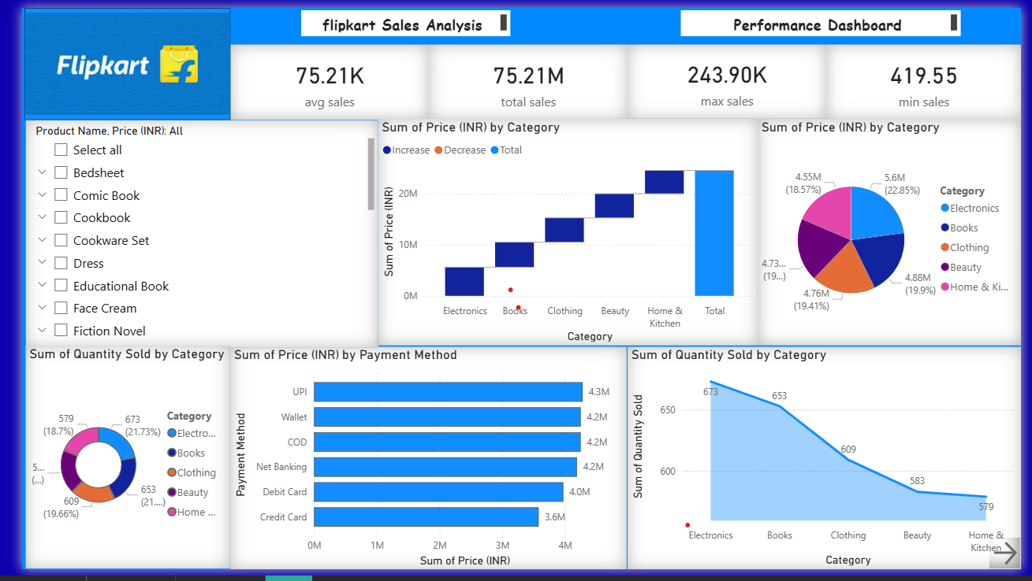
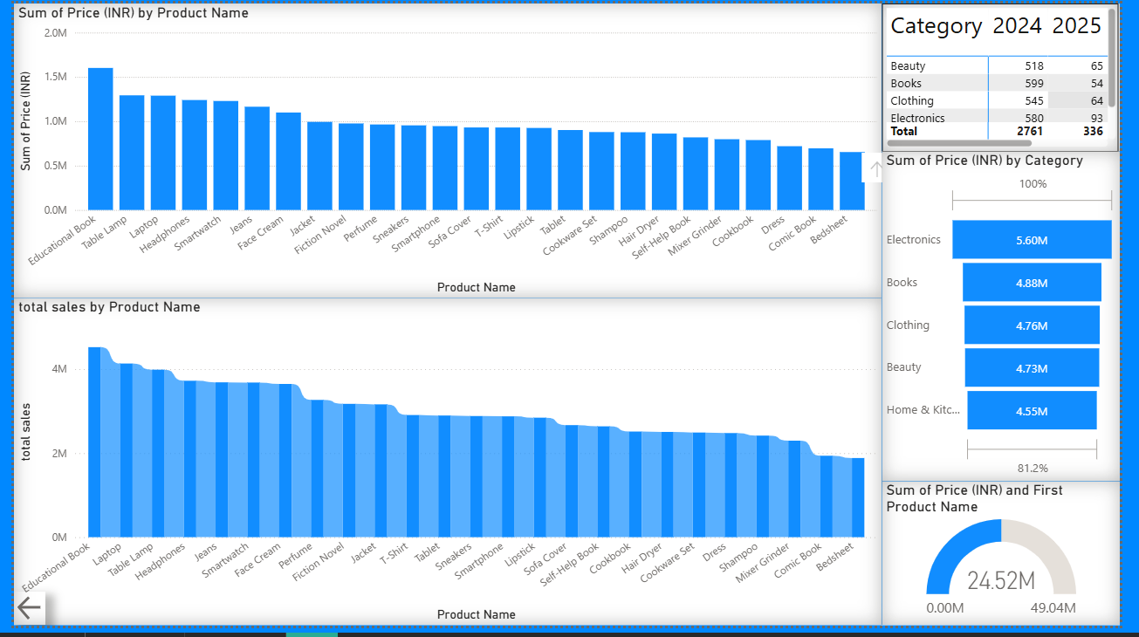
the page 2 includes of clustered column chart, matrix table, ribbon chart, funnel chart and gauge.

7.Conclusion
In this project I have learn how to do an dashboard in power BI and using of query, filters and visualisation.
The Flipkart sales analysis conducted through Power BI provides meaningful insights into customer purchase behaviour, product performance, and overall business trends. The dashboards reveal clear patterns in sales volume, revenue contribution, seasonal demand fluctuations, and the role of different categories in driving overall performance. High-performing products and regions demonstrate strong sales consistency, while low-performing segments highlight opportunities for targeted promotional strategies and assortment optimization.
By integrating visual analytics, the dataset enables quick identification of key business drivers, helps monitor KPIs, and supports data-driven decision making. The insights suggest that improving product availability, optimizing pricing strategies, and enhancing customer experience could significantly boost sales outcomes. Overall, Power BI proves to be an effective tool for analysing Flipkart’s sales data, enabling deeper business intelligence and supporting strategic planning for growth and competitiveness.

